**SMART SOLUTIONS FOR RAILWAYS**

M.SNEHA (21021910605),S.OVIYA (210219106027), J.BANUPRIYA(210219106007),

R.SAKTHI (210219106031)

**Department of Electronics Communication Engineering, Apollo Engineering College**

|  |  |
| --- | --- |
| TEAM ID | PNT2022TMID36774 |
| PROJECT NAME | **Smart Solutions For Railways** |
| TEAM LEADER | SNEHA.M |
| TEAM MEMBER 1 | OVIYA.S |
| TEAM MEMBER 2 | SAKTHI.R |
| TEAM MEMBER 3 | BANUPRIYA.J |

# 1. INTRODUCTION

## 1.1 PROJECT OVERVIEW

• smart solutions for railways is to manage Indian Railways is the largest railway network in Asia and additionally world's second largest network operated underneath a single management. Due to its large size it is difficult to monitor the cracks in tracks manually. This paper deals with this problem and detects cracks in tracks with the help of ultrasonic sensor attached to moving assembly with help of stepper motor. Ultrasonic sensor allows the device to moves back and forth across the track and if there is any fault, it gives information to the cloud server through which railway department is informed on time about cracks and many lives can be saved. This is the application of IoT, due to this it is cost effective system. This effective methodology of continuous observation and assessment of rail tracks might facilitate to stop accidents. This methodology endlessly monitors the rail stress, evaluate the results and provide the rail break alerts such as potential buckling conditions, bending of rails and wheel impact load detection to the concerned authorities**.**

.

## 1.2 PURPOSE

Internet is basically system of interconnected computers through network. But now its use is changing with changing world and it is not just confined to emails or web browsing. Today’s internet also deals with embedded sensors and has led to development of smart homes, smart rural area, e-health care’s etc. and this introduced the concept of IoT . Internet of Things refers to interconnection or communication between two or more devices without humantohuman and humanto-computer interaction. Connected devices are equipped with sensors or actuators perceive their surroundings. IOT has four major components which include sensing the device, accessing the device, processing the information of the device, and provides application and services. In addition to this it also provides security and privacy of data . Automation has affected every aspect of our daily lives. More improvements are being introduced in almost all fields to reduce human effort and save time. Thinking of the same is trying to introduce automation in the field of track testing. Railroad track is an integral part of any company's asset base, since it provides them with the necessary business functionality. Problems that occur due to problems in railroads need to be overcome. The latest method used by the Indian railroad is the tracking of the train track which requires a lot of manpower and is time-consuming

# 2. LITERATURE SURVEY

## 2.1 EXISTING PROBLEM

In the Existing train tracks are manually researched. LED (Light Emitting Diode) and LDR (Light Dependent Resister) sensors cannot be implemented on the block of the tracks ]. The input image processing is a clamorous system with high cost and does not give the exact result. The Automated Visual Test Method is a complicated method as the video color inspection is implemented to examine the cracks in rail track which does not give accurate result in bad weather. This traditional system delays transfer of information. Srivastava et al., (2017) proposed a moving gadget to detect the cracks with the help of an array of IR sensors to identify the actual position of the cracks as well as notify to nearest railway station . Mishra et al., (2019) developed a system to track the cracks with the help ofArduino mega power using solar energy and laser. A GSM along with a GPS module was implemented to get the actual location of the faulty tracks to inform the authorities using SMS via a link to find actual location on Google Maps. Rizvi Aliza Raza presented a prototype in that is capable of capturing photos of the track and compare it with the old database and sends a message to the authorities regarding the crack detected. The detailed analysis of traditional railway track fault detection techniques is explained in table

## 2.2 REFERENCES

1. D. Hesse, “Rail Inspection Using Ultrasonic Surface Waves” Thesis, Imperial College of London, 2007.
2. Md. Reya Shad Azim1 , Khizir Mahmud2 and C. K. Das. Automatic railway track switching system, International Journal of Advanced Technology, Volume 54, 2014.
3. S. Somalraju, V. Murali, G. saha and V. Vaidehi, “Title-robust railway crack detection scheme using LED (Light Emitting Diode) - LDR (Light Dependent Resistor) assembly IEEE 2012.
4. S. Srivastava, R. P. Chourasia, P. Sharma, S. I. Abbas, N. K. Singh, “Railway

Track Crack detection vehicle”, IARJSET, Vol. 4, pp. 145-148, Issued in 2, Feb 2017.

1. U. Mishra, V. Gupta, S. M. Ahzam and S. M. Tripathi, “Google Map Based

Railway Track Fault Detection Over the Internet”, International Journal of Applied Engineering Research, Vol. 14, pp. 20-23, Number 2, 2019.

1. R. A. Raza, K. P. Rauf, A. Shafeeq, “Crack detection in Railway track using Image processing”, IJARIIT, Vol. 3, pp. 489-496, Issue 4, 2017.
2. N. Bhargav, A. Gupta, M. Khirwar, S. Yadav, and V. Sahu, “Automatic Fault

Detection of Railway Track System Based on PLC (ADOR TAST)”, International Journal of Recent Research Aspects, Vol. 3, pp. 91-94, 2016

## 2.3 PROBLEM STATEMENT DEFINITION

Among the various modes of transport, railways is one of the biggest modes of transport in the world. Though there are competitive threats from airlines, luxury buses, public transports, and personalized transports the problem statement is to answer the question “What are the problems faced by the passengers while travelling by train at station and on board”

# 3. IDEATION & PROPOSED SOLUTION

## 3.1 EMPATHY MAP CANVAS

An Empathy map is a collaborative tool teams can use to gain smart railways for customers. Much like a user persona, an empathy map can represent a group of users, such as a customer segment. Our empathy map canvas is shown assmart solutions for railways.

The Thinksquadrant captures what the user is thinking throughout the experience. It is possible to have the same content in both Says and Thinks. However, pay special attention to what users think, but may not be willing to vocalize. Try to understand why they are reluctant to share — are they unsure, self-conscious, polite, or afraid to tell others something

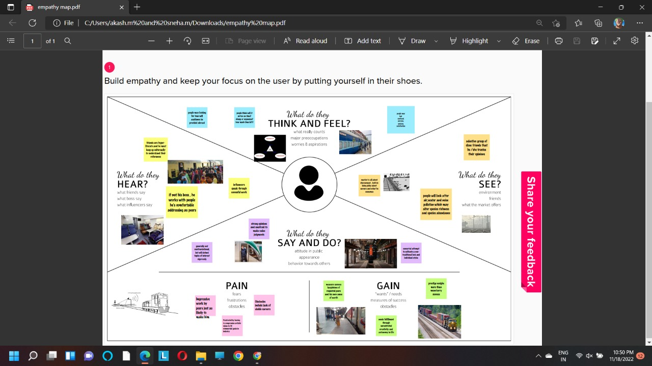

## 3.2 IDEATION & BRAINSTORMING

Ideation refers to the hole creative process of coming up with and communicating new ideas.It can take many different forms,from coming up with a totally new idea to combining multiple existing ideas to create a new process or organizational system.Ideation is similar to a pratice known as brainstorming.

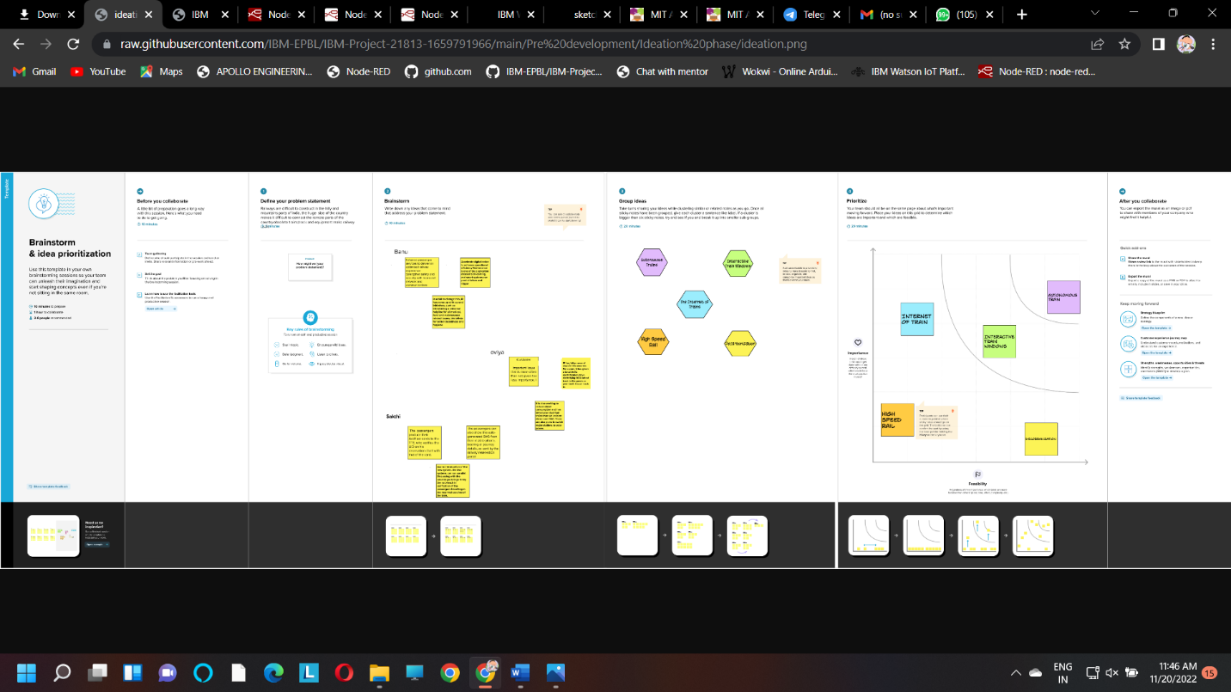

## 3.3 PROPOSED SOLUTION

Proposed Solution means the technical solution to be provide by the implementation agency in response to the requirements and the objectives of the project. he following information may be useful to you in completing this portion of your team’s work. Skim this section, then refer back to it as necessary.

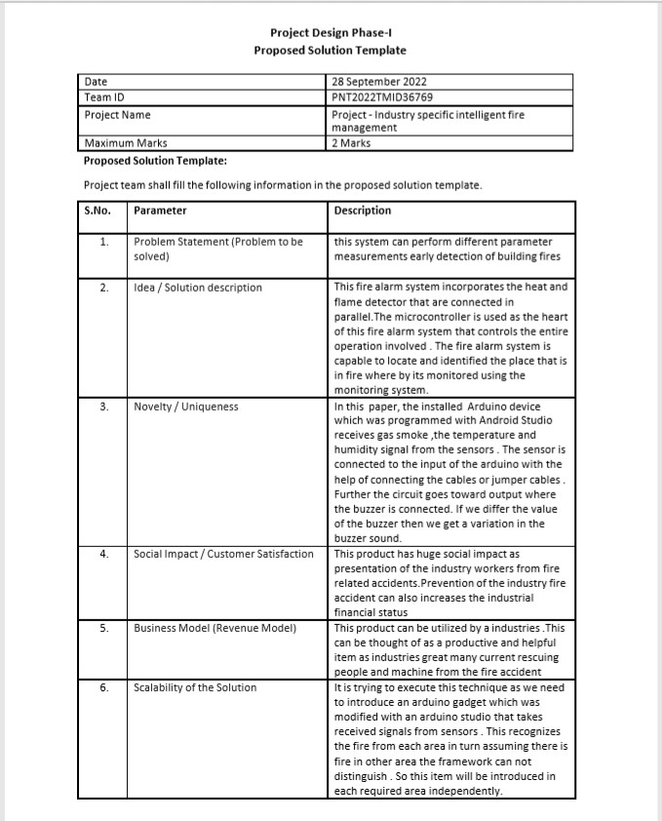

## 3.4 PROBLEM SOLUTION FIT

Problem solving is the act of defining a problem; determining the cause of the problem; identifying, prioritizing, and selecting alternatives for a solution; and implementing a solution. In order to effectively manage and run a successful organization, leadership must guide their employees and develop problem-solving techniques. Finding a suitable solution for issues can be accomplished by following the basic four-step problem-solving process and methodology outlined below.

PROJECT DESIGN PHASE – I

PROBLEM SOLUTION FIT

|  |  |
| --- | --- |
| DATE | 27 SEPTEMBER 2022 |
| TEAM ID | PNT2022TMID36774 |
| PROJECT NAME | Smart Solutions For Railways |
| MAXIMUM MARKS | 2 Marks |

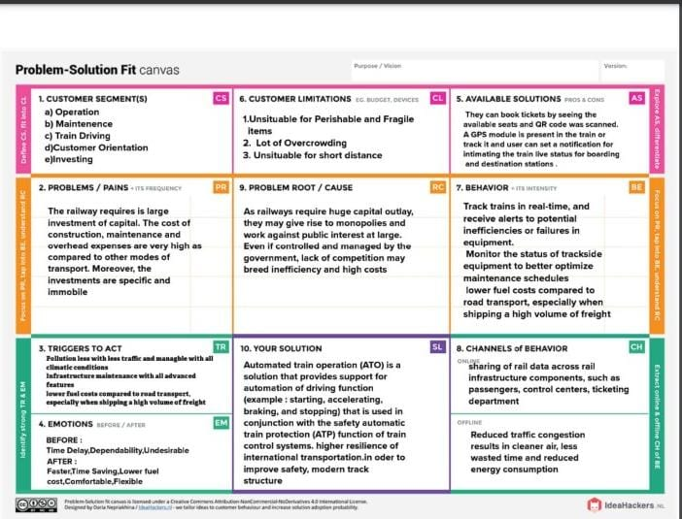

# 4. REQUIREMENT ANALYSIS

Requirement analysis also called as requirement engineering is the process of determining user expectation for a new or modified product. These features are called requirement must be qualifiable relevant and detailed. Its classified as two major type.

## 4.1 FUNCTIONAL REQUIREMENT

The FlameRanger system, jointly presented by Unifire AB & Tyco, meet or exceed all of the functions described above, and all of the specifications set out in the functional Requisition.

## 4.2 NON-FUNCTIONAL REQUIREMENT

NFR generally stated, often contracdictory, difficult to enforce during development and evaluate for the customer prior to delivery.

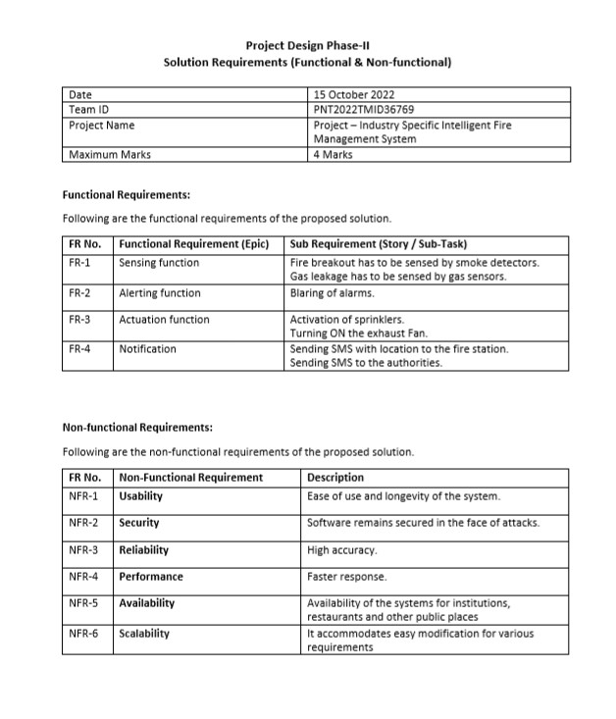

# 5. PROJECT DESIGN

## 5.1 DATA FLOW DIAGRAM

Data flow diagram is a way of representing a flow of data through a processer or a system. A data flow diagram as no control flow they are no decision rules and no loops.

|  |  |
| --- | --- |
| Date | 09 November 2022 |
| Team ID | PNT2022TMID36774 |
| Project Name | Smart Solutions For Railways |
| Maximum Marks | 4 Marks |

**DATA FLOW DIAGRAM:**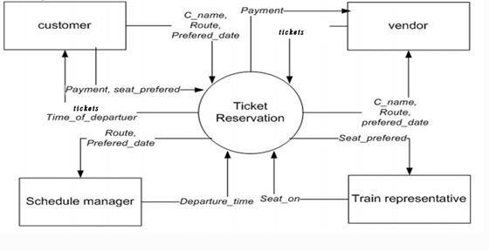

## 5.2 SOLUTION & TECHNICAL ARCHITECTURE

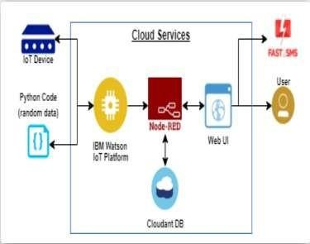

A Solution architecture is an architectural description of a specific solution. SAs combine guidance from different enterprise architectural viewpoints (business, information and technical) as well as from the enterprise solution architecture (ESA).

## 5.3 USER STORIES

(1)Information collection module In order to realize the real-time collection and update of the information and ensure the accuracy of the information, the existing internet of things equipment such as monitoring, smoke feeling, fire control sign and so on are used to collect the field information and efficiently understand the situation on the spot. (2)Model module The BIM model of the building is established by using BIM technology. The model includes the information of all the components in the building, the information of water, electricity and gas and all the information of fire extinguishing equipment, thus which can provide data support for indoor escape and rescue of building firefighting. (3)Intelligent processing module The intelligent processing module can automatically plan the rescue path, rescue tools, indoor escape path, and modify the contents of fire protection sign by synthetically processing the data of the information collection module and the model module. (4)Decision module The rescue center reads the information on the equipment and models of internet of things, and other information through the decision module, and issues the emergency evacuation command, at the same time, which chooses the outdoor rescue routes and rescue tools, and sends rescue orders to the rescue teams. (5)Information feedback module After the decision is made, the information feedback module automatically releases the best escape route to the survivors, and indicates the location of the fire rescue tools nearby, besides provides the best rescue route, rescue ways, rescue tools and other information to the rescuers, and relieves the alarm in time after the rescuing. (6)Escape terminal APP module

# 6. PROJECT PLANNING & SCHEDULING

## 6.1 SPRINT PLANNING & ESTIMATION

Sprint planning is an event in scrum that kicks of the sprint. The purpose of sprint planning is to define what we can deliver in the sprint and how that work will be achieved. Sprint planning is done in collaboration with the whole scrum team

.

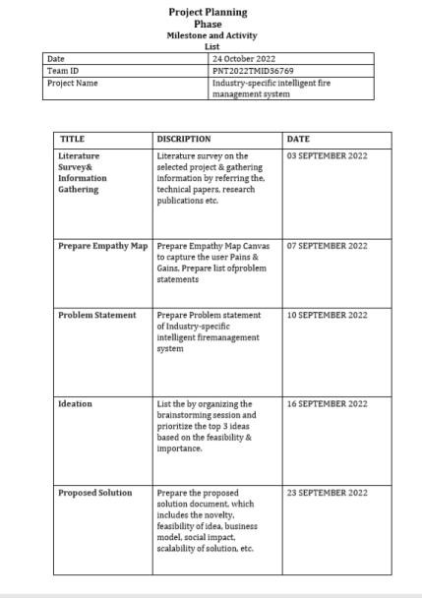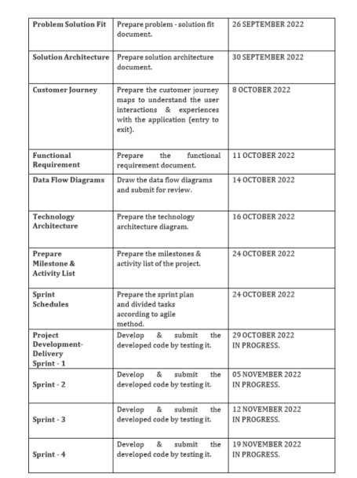

### 6.2 SPRINT DELIVERY SCHEDULE

The deliverables of the sprint are not as predictable as they are for the other project. Sprint participance have produced sketches and drawing, writing, photograph, comic, strip, video and fully coded working prototypes

**Project Planning Phase**

**Project Planning Template (Product Backlog, Sprint Planning, Stories, Story points)**

|  |  |
| --- | --- |
| Date | 09 NOVEMBER 2022 |
| Team ID | PNT2022TMID36774 |
| Project Name | Smart Solutions For Railways |
| Maximum Marks | 8 Marks |

**Product Backlog, Sprint Schedule, and Estimation (4 Marks)**

Use the below template to create product backlog and sprint schedule

|  |  |  |  |  |  |  |
| --- | --- | --- | --- | --- | --- | --- |
| **Sprint** | **Functional**  **Requirement (Epic)** | **User Story**  **Number** | **User Story / Task** | **Story Points** | **Priority** | **Team**  **Members** |
| Sprint-1 | Registration | USN-1 | As a user, I can register through the form by Filling in my details | 2 | High | sneha |
| Sprint-1 |  | USN-2 | As a user, I can register through phone numbers, Gmail, Facebook or other social sites | 1 | High | sakthi |
| Sprint-1 | Conformation | USN-3 | As a user, I will receive confirmation through email or OTP once registration is successful | 2 | Low | oviya |
| Sprint-1 | login | USN-4 | As a user, I can login via login id and password or through OTP received on register phone number | 2 | Medium | banupriya |
| Sprint-1 | Display Train details | USN-5 | As a user, I can enter the start and destination to get the list of trains available connecting the above | 1 | High | sneha |
| Sprint-2 | Booking | USN-6 | As a use, I can provide the basic details such as a name, age, gender etc… | 2 | High | sakthi |
| Sprint-2 |  | USN-7 | As a user, I can choose the class, seat/berth. If a preferred seat/berth isn’t available I can be allocated based on the availability | 1 | Low | oviya |
| Sprint-2 | Payment | USN-8 | As a user, I can choose to pay through credit Card/debit card/UPI. | 1 | High | banupriya |
| **Sprint** | **Functional**  **Requirement (Epic)** | **User Story**  **Number** | **User Story / Task** | **Story Points** | **Priority** | **Team**  **Members** |
| Sprint-2 |  | USN-9 | As a user, I will be redirected to the selected | 2 | High | sneha |
| Sprint-3 | Ticket generation | USN-10 | As a user, I can download the generated eticket for my journey along with the QR code which is used for authentication during my journey. | 1 | High | Sakthi |
| Sprint-3 | Ticket status | USN-11 | As a user, I can see the status of my ticket Whether it’s confirmed/waiting/RAC. | 2 | High | Oviya |
| Sprint-3 | Remainders notification | USN-12 | As a user, I get remainders about my journey A day before my actual journey. | 1 | High | banupriya |
| Sprint-3 | Ticket cancellation | USN-13 | As a user, I can track the train using GPS and can get information such as ETA, Current stop and delay | 2 | High | Sneha |
| Sprint-4 |  | USN-14 | As a user, I can cancel my tickets if there’s any Change of plan | 1 | High | Sakthi |
| Sprint-4 | Raise queries | USN-15 | As a user, I can raise queries through the query box or via mail. | 2 | Medium | Oviya |
| Sprint-4 | Answer the queries | USN-16 | As a user, I will answer the questions/doubts Raised by the customers. | 2 | High | banupriya |
| Sprint-4 | Feed details | USN-17 | As a user, I will feed information about the trains delays and add extra seats if a new compartment is added. | 1 | High | sneha |

**Project Tracker, Velocity & Burndown Chart: (4 Marks)**

|  |  |  |  |  |  |  |
| --- | --- | --- | --- | --- | --- | --- |
| **Sprint** | **Total Story Points** | **Duration** | **Sprint Start Date** | **Sprint End Date (Planned)** | **Story Points**  **Completed (as on**  **Planned End Date)** | **Sprint Release Date (Actual)** |
| Sprint-1 | 20 | 6 Days | 24 Oct 2022 | 29 Oct 2022 | 20 | 29 Oct 2022 |
| Sprint-2 | 20 | 6 Days | 31 Oct 2022 | 05 Nov 2022 | 20 | 5 Nov 2022 |
| Sprint-3 | 20 | 6 Days | 07 Nov 2022 | 12 Nov 2022 | 20 | 12 Nov 2022 |
| Sprint-4 | 20 | 6 Days | 14 Nov 2022 | 19 Nov 2022 | 20 | 19 Nov 2022 |

**Velocity:**

Imagine we have a 10-day sprint duration, and the velocity of the team is 20 (points per sprint). Let’s calculate the team’s average velocity (AV) per iteration unit (story points per day)

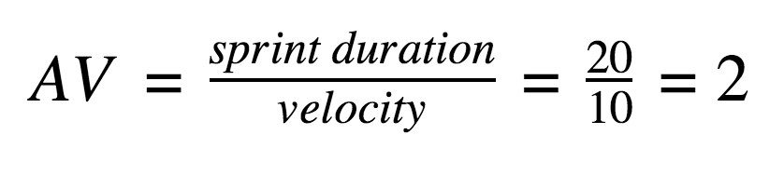

**7. CODING & SOLUTIONING**

## FEATURE

#include <WiFi.h>//library for wifi

#include <PubSubClient.h>//library for MQtt

#include "DHT.h"// Library for dht11

#define DHTPIN 15 // what pin we're connected to

#define DHTTYPE DHT22 // define type of sensor DHT 11

#define LED 2

DHT dht (DHTPIN, DHTTYPE);// creating the instance by passing pin and typr of dht connected void callback(char* subscribetopic, byte* payload, unsigned int payloadLength);

//-------credentials of IBM Accounts------

#define ORG "zbgr67"//IBM ORGANITION ID

#define DEVICE_TYPE "fershidevicetype"//Device type mentioned in ibm watson IOT Platform

#define DEVICE_ID "fershideviceid"//Device ID mentioned in ibm watson IOT

Platform

#define TOKEN "fershiageona" //Token String data3; float t;

//-------- Customise the above values -------- char server[] = ORG ".messaging.internetofthings.ibmcloud.com";// Server Name char publishTopic[] = "iot-2/evt/Data/fmt/json";// topic name and type of event perform and format in which data to be send char subscribetopic[] = "iot-2/cmd/command/fmt/String";// cmd REPRESENT command type AND COMMAND IS TEST OF FORMAT STRING char authMethod[] = "use-token-auth";// authentication method char token[] = TOKEN;

char clientId[] = "d:" ORG ":" DEVICE_TYPE ":" DEVICE_ID;//client id

//-----------------------------------------

WiFiClient wifiClient; // creating the instance for wificlient

PubSubClient client(server, 1883, callback ,wifiClient); //calling the predefined client id by passing parameter like server id,portand wificredential void setup()// configureing the ESP32

{

**Serial**.begin(115200); dht.begin(); pinMode(LED,OUTPUT); delay(10); **Serial**.println(); wificonnect(); mqttconnect();

} void loop()// Recursive Function

{

t = dht.readTemperature();

**Serial**.print("temperature:");

**Serial**.println(t);

PublishData(t); delay(1000); if (!client.loop()) { mqttconnect();

}

}

/*.....................................retrieving to

Cloud...............................*/

void PublishData(float temp) { mqttconnect();//function call for connecting to ibm

/* creating the String in in form JSon to update the data to ibm cloud

*/

String payload = "{\"temperature\":"; payload += temp; payload += "}";

**Serial**.print("Sending payload: ");

**Serial**.println(payload);

if (client.publish(publishTopic, (char*) payload.c_str())) {

**Serial**.println("Publish ok");// if it sucessfully upload data on the cloud then it will print publish ok in Serial monitor or else it will print publish failed

} else {

**Serial**.println("Publish failed");

}

} void mqttconnect() { if (!client.connected()) {

**Serial**.print("Reconnecting client to "); **Serial**.println(server);

while (!!!client.connect(clientId, authMethod, token)) { **Serial**.print("."); delay(500);

}

initManagedDevice();

**Serial**.println();

} } void wificonnect() //function defination for wificonnect {

**Serial**.println();

**Serial**.print("Connecting to ");

WiFi.begin("Wokwi-GUEST", "", 6);//passing the wifi credentials to establish the connection while (WiFi.status() != WL_CONNECTED) { delay(500);

**Serial**.print(".");

}

**Serial**.println("");

**Serial**.println("WiFi connected");

**Serial**.println("IP address: ");

**Serial**.println(WiFi.localIP());

} void initManagedDevice() {

if (client.subscribe(subscribetopic)) { **Serial**.println((subscribetopic));

**Serial**.println("subscribe to cmd OK");

} else {

**Serial**.println("subscribe to cmd FAILED");

}

}

void callback(char* subscribetopic, byte* payload, unsigned int payloadLength)

{

**Serial**.print("callback invoked for topic: ");

**Serial**.println(subscribetopic);

for (int i = 0; i < payloadLength; i++) { //Serial.print((char)payload[i]); data3 += (char)payload[i];

}

**Serial**.println("data: "+ data3); if(data3=="lighton") {

**Serial**.println(data3); digitalWrite(LED,HIGH);

} else

{

**Serial**.println(data3); digitalWrite(LED,LOW);

} data3="";

}

# TESTING

**8.1 Test Cases**

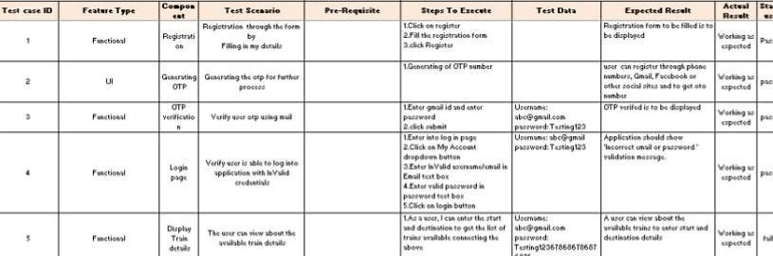

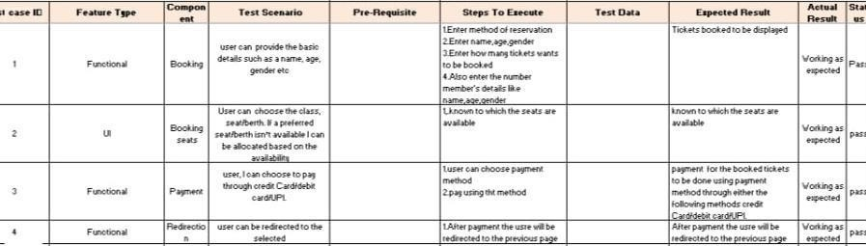

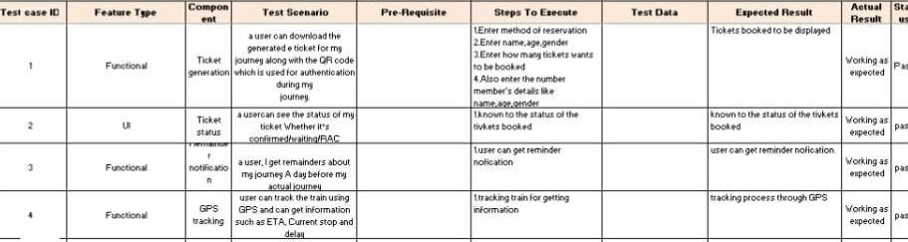

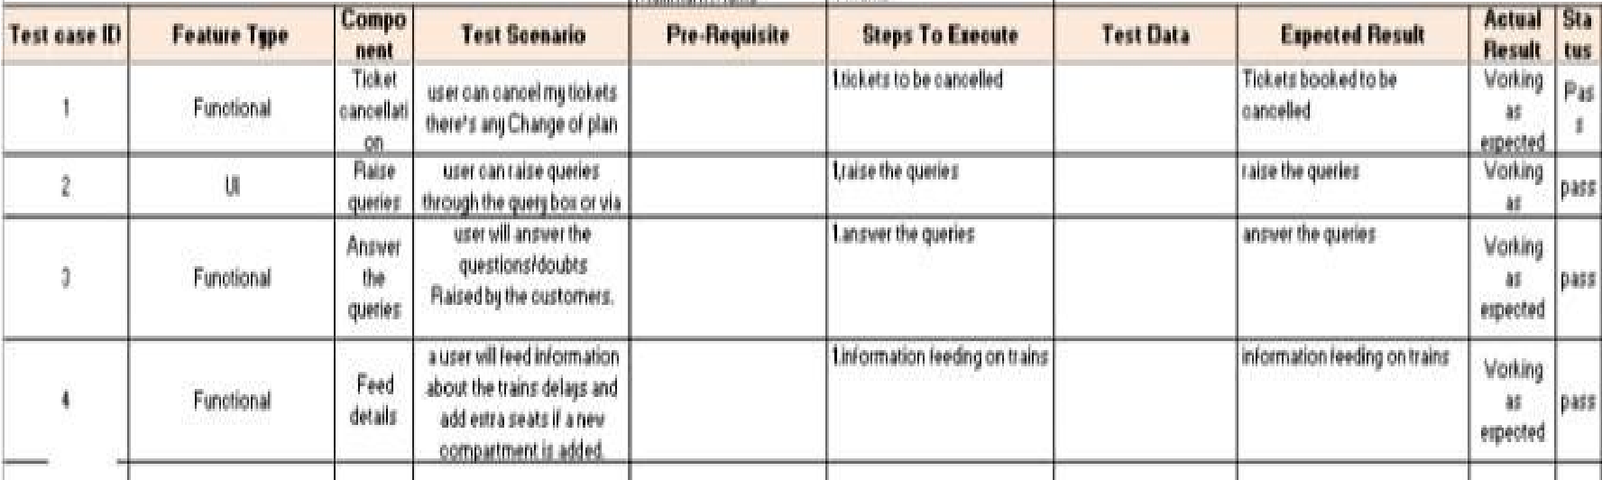

**8.2 User** **Acceptance Testing**

You must **test timings and seat allotment and with Qrcode correction in apk place to ensure where to start and where to end** . You may test with local trains and identified in the manufacturer's published instructions.

|  |  |
| --- | --- |
|  | 1. **RESULTS**     We have successfully used to built a web based UI and integrated all the servies using Node  RED web Application: https://node-red-brcrj-2022-11-18.eu-gb.mybluemix.net/red/#flow/e9522b9f8417b54d     1. **ADVANTAGES & DISADVANTAGES**     **ADVANTAGES OF INTELLIGENT FIRE ALARM SYSTEM:** |
| • | Openness – compatibility between different system modules, potentially from different vendors; |
| **•** | Orchestration – ability to manage large numbers of devices, with full visibility over them; o Dynamic scaling – ability to scale the system according to the application needs, through resource virtualization and cloud operation |
| • | Automation – ability to automate parts of the system monitoring application, leading to better performance and lower operation costs |
|  | **DISADVANTAGES** |
| • | Approaches to flexible, effective, efficient, and low-cost data collection for both railway vehicles and infrastructure monitoring, using regular trains |
| • | Data processing, reduction, and analysis in local controllers, and subsequent sending of that data to the cloud, for further processing |
| • | Online data processing systems, for real-time monitoring, using emerging communication technologies; Integrated, interoperable, and scalable solutions for railway systems preventive maintenance      **11. CONCLUSION**    Accidents occurring in Railway transportation system cost a large number of lives. So this system helps us to prevent accidents and giving information about faults or cracks in advance to railway authorities. So that they can fix them and accidents cases becomes less. This project is cost effective. By using more techniques they can be modified and developed according to their applications. By this system many lives can be saved by avoiding accidents. The idea can be implemented in large scale in the long run to facilitate better safety standards for rail tracks and provide effective testing infrastructure for achieving better results in the future. |

# 12. FUTURE SCOPE

In future CCTV systems with IP based camera can be used for monitoring the visual videos captured from the track. It will also increase security for both passengers and railways. GPS can also be used to detect exact location of track fault area, IP cameras can also be used to show fault with the help of video. Locations on Google maps with the help of sensors can be used to detect in which area track is broken

# 13. APPENDIX

## Source Code

#include <WiFi.h>//library for wifi

#include <PubSubClient.h>//library for MQtt

#include "DHT.h"// Library for dht11

#define DHTPIN 15 // what pin we're connected to

#define DHTTYPE DHT22 // define type of sensor DHT 11

#define LED 2

DHT dht (DHTPIN, DHTTYPE);// creating the instance by passing pin and typr of dht connected void callback(char* subscribetopic, byte* payload, unsigned int payloadLength);

//-------credentials of IBM Accounts------

#define ORG "zbgr67"//IBM ORGANITION ID

#define DEVICE_TYPE "fershidevicetype"//Device type mentioned in ibm watson IOT Platform

#define DEVICE_ID "fershideviceid"//Device ID mentioned in ibm watson IOT

Platform

#define TOKEN "fershiageona" //Token String data3; float t;

//-------- Customise the above values -------- char server[] = ORG ".messaging.internetofthings.ibmcloud.com";// Server Name char publishTopic[] = "iot-2/evt/Data/fmt/json";// topic name and type of event perform and format in which data to be send

char subscribetopic[] = "iot-2/cmd/command/fmt/String";// cmd REPRESENT command type AND COMMAND IS TEST OF FORMAT STRING char authMethod[] = "use-token-auth";// authentication method char token[] = TOKEN; char clientId[] = "d:" ORG ":" DEVICE_TYPE ":" DEVICE_ID;//client id

//-----------------------------------------

WiFiClient wifiClient; // creating the instance for wificlient

PubSubClient client(server, 1883, callback ,wifiClient); //calling the predefined client id by passing parameter like server id,portand wificredential void setup()// configureing the ESP32

{

**Serial**.begin(115200); dht.begin(); pinMode(LED,OUTPUT); delay(10); **Serial**.println(); wificonnect(); mqttconnect();

} void loop()// Recursive Function

{

t = dht.readTemperature();

**Serial**.print("temperature:");

**Serial**.println(t);

PublishData(t); delay(1000); if (!client.loop()) { mqttconnect();

}

}

/*.....................................retrieving to

Cloud...............................*/

void PublishData(float temp) {

mqttconnect();//function call for connecting to ibm

/* creating the String in in form JSon to update the data to ibm cloud */

String payload = "{\"temperature\":"; payload += temp; payload += "}";

**Serial**.print("Sending payload: ");

**Serial**.println(payload);

if (client.publish(publishTopic, (char*) payload.c_str())) {

**Serial**.println("Publish ok");// if it sucessfully upload data on the cloud then it will print publish ok in Serial monitor or else it will print publish failed

} else {

**Serial**.println("Publish failed");

}

} void mqttconnect() { if (!client.connected()) {

**Serial**.print("Reconnecting client to "); **Serial**.println(server);

while (!!!client.connect(clientId, authMethod, token)) { **Serial**.print("."); delay(500);

}

initManagedDevice();

**Serial**.println();

} } void wificonnect() //function defination for wificonnect

{

**Serial**.println();

**Serial**.print("Connecting to ");

WiFi.begin("Wokwi-GUEST", "", 6);//passing the wifi credentials to establish the connection while (WiFi.status() != WL_CONNECTED) { delay(500);

**Serial**.print(".");

}

**Serial**.println("");

**Serial**.println("WiFi connected");

**Serial**.println("IP address: ");

**Serial**.println(WiFi.localIP());

} void initManagedDevice() {

if (client.subscribe(subscribetopic)) { **Serial**.println((subscribetopic));

**Serial**.println("subscribe to cmd OK");

} else {

**Serial**.println("subscribe to cmd FAILED");

}

} void callback(char* subscribetopic, byte* payload, unsigned int payloadLength)

{

**Serial**.print("callback invoked for topic: "); **Serial**.println(subscribetopic); for (int i = 0; i < payloadLength; i++) { //Serial.print((char)payload[i]); data3 += (char)payload[i];

}

**Serial**.println("data: "+ data3); if(data3=="lighton") {

**Serial**.println(data3); digitalWrite(LED,HIGH);

} else

{

**Serial**.println(data3); digitalWrite(LED,LOW);

} data3="";

}

## GitHub link : https://github.com/IBM-EPBL/IBM-Project-21813-1659791966.git

**DEMO LINK:** **https://github.com/IBM-EPBL/IBM-Project-21813-1659791966/blob/main/FINAL%20DELIVERABLES/demo%20video.mp4**